MINI Power Meter FB-20 Series

MINI Hand Held optical power meter series products are mainly used for continuous optical signal power measurement, optical fiber link loss testing and optical fiber line on-off testing.

It is controlled by a single chip microprocessor with complete functions. Widely used in optical cable construction and maintenance, optical fiber communication, optical cable sensing, optical CATV and other fields.

It adopts advanced thermoplastic molding technology, which is compact, beautiful and durable.

Functions | 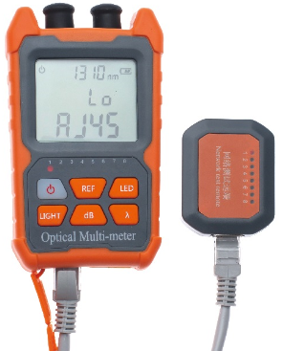  Options
Automatic power off. | SC,FC,ST interface, FC connector as default.
Background light switch. | Network cable tester (It can check if the signal is transmitting in network cable)
Wavelength memory | AAA battery or Lithium battery.
Restore factory setting | 1mw / 2mw / 10mw VFL as options.
User Self-calibration
External power supply such as
charging treasure, computer, etc.
Simultaneous linear(mW) and non-linear(dBm) display.

Technical Parameter

Type | A | B
Wavelength Range | 800~1700 | 800~1700
Connector | FC/SC/ST | FC/SC/ST
Type of connector | InGaAs | InGaAs
Power measurement range(dBm) | -70~+6 | -50~+26
Uncertainty | ±5%
Standard wavelength(nm) | 850/980/1300/1310/1490/1550/1625/1650
Display Resolution | Linear display: 0.1% ; logarithmic display: 0.01dBm
650nm light source(optional) | 1mw/10mw/20mw/30mw/50mw
Operating temperature | -10~+60
Storage temperature | -30~+70
Automatic shutdown time(min) | 10
Continuous working hours of batteries(h) | >72
Instrument size (mm) | 112x66x30
Power supply | 2pcs AAA batteries /Rechargeable Lithium Batteries (options)
Instrument net weight (g) | 140g/150g
Note: we have several optional configurations for your selection. Pls. talk with us for details.

